34.117: a) The distance between image and object can be calculated by taking the derivative of the separation distance and minimizing it.
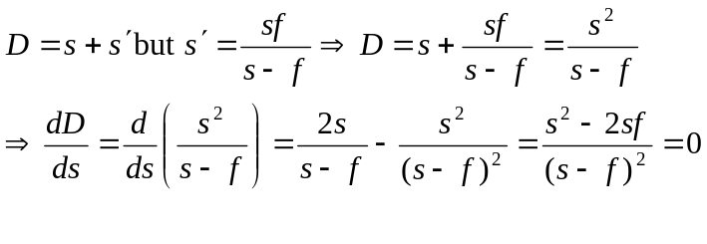
so for a real image, the minimum separation between object and image is 4f.
b)
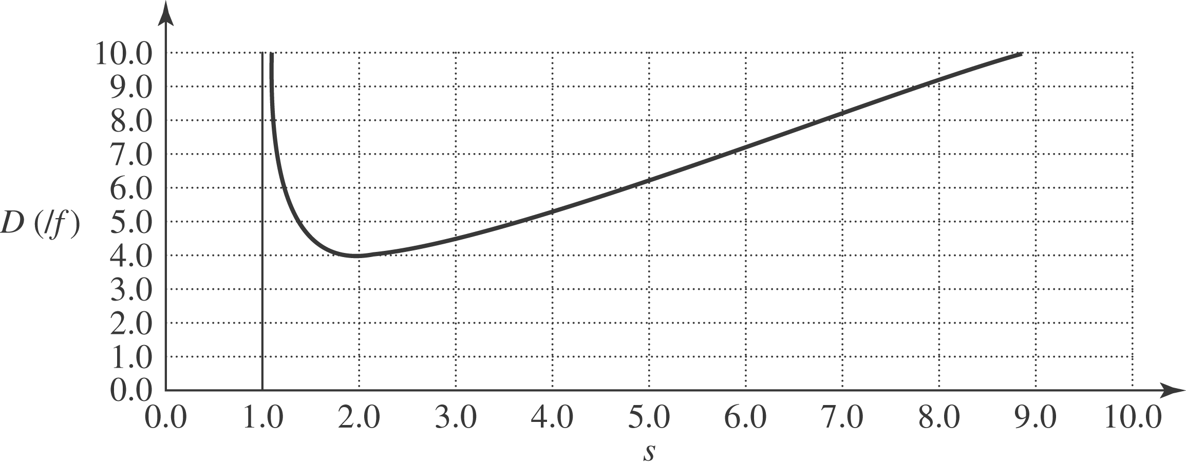

Note that the minimum does occur for D=4f.

